Aarush Khandelwal
24UADS1001
Neural Network Exp. 1
B.E. 3rd year (6th sem)

1. Code:
import numpy as np
import matplotlib.pyplot as plt
from sklearn.datasets import make_classification
from matplotlib.animation import FuncAnimation
from IPython.display import HTML

X, y = make_classification(
n_samples=100,
n_features=2,
n_informative=1,
n_redundant=0,
n_classes=2,
n_clusters_per_class=1,
random_state=50,
hypercube=False,
class_sep=10
)

y = np.where(y == 0, -1, 1)

plt.figure(figsize=(8,6))
plt.scatter(X[:,0], X[:,1], c=y, cmap='winter', s=70)
plt.title("Training Data")
plt.show()

def step(z):
return 1 if z >= 0 else -1

def perceptron(X, y, lr=1.0, epochs=100):
X = np.insert(X, 0, 1, axis=1)
weights = np.zeros(X.shape[1])

slopes = []
intercepts = []

print("PERCEPTRON TRAINING")
for epoch in range(epochs):
errors = 0
print(f"\nEpoch {epoch+1}")

for i in range(len(X)):
x_i = X[i]
y_i = y[i]

activation = np.dot(weights, x_i)
y_hat = step(activation)

print("x :", x_i)
print("w :", weights)
print("w.T * x :", activation)

if y_i != y_hat:
weights = weights + lr * y_i * x_i
errors += 1

slopes.append(-weights[1] / weights[2])
intercepts.append(-weights[0] / weights[2])

if errors == 0:
print("\nConverged early ✔")
break

print("\nFinal weights:", weights)
return weights, slopes, intercepts

weights, m, b = perceptron(X, y)

fig, ax = plt.subplots(figsize=(7, 5))
ax.scatter(X[:,0], X[:,1], c=y, cmap='winter', s=70)

x_vals = np.linspace(X[:,0].min()-1, X[:,0].max()+1, 100)
line, = ax.plot(x_vals, m[0]*x_vals + b[0], 'r-', linewidth=2)

def update(i):
line.set_ydata(m[i]*x_vals + b[i])
ax.set_title(f"Perceptron Learning | Step {i+1}")
return line,

anim = FuncAnimation(
fig,
update,
frames=len(m),
interval=120,
repeat=False
)

plt.tight_layout()
HTML(anim.to_jshtml())

2. Values of w, X, w.T*x:
PERCEPTRON TRAINING

Epoch 1
x : [ 1. 0.18700093 -0.10267613]
w : [0. 0. 0.]
w.T * x : 0.0
x : [1. 0.76285136 0.16551597]
w : [0. 0. 0.]
w.T * x : 0.0
x : [ 1. -1.12368559 -0.80692205]
w : [0. 0. 0.]
w.T * x : 0.0
x : [ 1. 0.59933142 -1.00848994]
w : [-1. 1.12368559 0.80692205]
w.T * x : -1.140312697983872
x : [ 1. -1.57267146 -1.65504883]
w : [ 0. 1.72301701 -0.20156789]
w.T * x : -2.376134965755768
x : [ 1. -1.21692697 0.09614299]
w : [ 0. 1.72301701 -0.20156789]
w.T * x : -2.1161651998084343
x : [1. 0.38562534 0.47195759]
w : [ 0. 1.72301701 -0.20156789]
w.T * x : 0.5693075144901942
x : [ 1. -0.86299198 0.98332108]
w : [ 0. 1.72301701 -0.20156789]
w.T * x : -1.6851558204528854
x : [1. 0.4429556 1.15745829]
w : [ 0. 1.72301701 -0.20156789]
w.T * x : 0.5299136001432534
x : [ 1. -1.42636649 -1.72403377]
w : [ 0. 1.72301701 -0.20156789]
w.T * x : -2.110143862565731
x : [1. 0.42272296 0.48262513]
w : [ 0. 1.72301701 -0.20156789]
w.T * x : 0.6310771235293311
x : [ 1. 0.35944862 -0.37467293]
w : [ 0. 1.72301701 -0.20156789]
w.T * x : 0.6948581245046742
x : [ 1. 0.69278207 -0.06928971]
w : [ 0. 1.72301701 -0.20156789]
w.T * x : 1.2076418711437362
x : [ 1. -0.9426344 0.84505293]
w : [ 0. 1.72301701 -0.20156789]
w.T * x : -1.7945106462913072
x : [ 1. 0.43840538 -0.10827111]
w : [ 0. 1.72301701 -0.20156789]
w.T * x : 0.777203906738099
x : [ 1. -1.253949 1.64430655]
w : [ 0. 1.72301701 -0.20156789]
w.T * x : -2.4920148560142446
x : [1. 0.69404044 0.97642615]
w : [ 0. 1.72301701 -0.20156789]
w.T * x : 0.999027313930285
x : [ 1. -1.29123712 0.38953415]
w : [ 0. 1.72301701 -0.20156789]
w.T * x : -2.303341091309695
x : [ 1. 0.82342339 -1.56160189]
w : [ 0. 1.72301701 -0.20156789]
w.T * x : 1.7335413101184352
x : [ 1. 0.30431814 -1.60537487]
w : [ 0. 1.72301701 -0.20156789]
w.T * x : 0.8479373603793516
x : [ 1. -1.36508039 -0.24673883]
w : [ 0. 1.72301701 -0.20156789]
w.T * x : -2.302322093199762
x : [ 1. -1.55398004 -0.57548248]
w : [ 0. 1.72301701 -0.20156789]
w.T * x : -2.5615352530734206
x : [ 1. -1.2010848 0.08545142]
w : [ 0. 1.72301701 -0.20156789]
w.T * x : -2.0867137942076974
x : [ 1. -1.11758739 -1.73066509]
w : [ 0. 1.72301701 -0.20156789]
w.T * x : -1.5767755676817727
x : [ 1. -1.46642816 1.41669408]
w : [ 0. 1.72301701 -0.20156789]
w.T * x : -2.812240693298989
x : [ 1. -1.42259154 -0.39185323]
w : [ 0. 1.72301701 -0.20156789]
w.T * x : -2.3721643822178002
x : [1. 0.8841352 0.27995674]
w : [ 0. 1.72301701 -0.20156789]
w.T * x : 1.466949694325889
x : [ 1. 0.34748411 -0.4939654 ]
w : [ 0. 1.72301701 -0.20156789]
w.T * x : 0.6982885965716086
x : [ 1. 0.73198283 -0.79576835]
w : [ 0. 1.72301701 -0.20156789]
w.T * x : 1.4216202115757341
x : [1. 0.85023 0.01419607]
w : [ 0. 1.72301701 -0.20156789]
w.T * x : 1.4620992824816292
x : [ 1. 0.71871567 -0.04412818]
w : [ 0. 1.72301701 -0.20156789]
w.T * x : 1.2472541513182716
x : [ 1. -1.2327435 0.23214276]
w : [ 0. 1.72301701 -0.20156789]
w.T * x : -2.170830538681041
x : [1. 0.57576651 1.89737706]
w : [ 0. 1.72301701 -0.20156789]
w.T * x : 0.6096051854075816
x : [ 1. -1.1246109 -0.18264358]
w : [ 0. 1.72301701 -0.20156789]
w.T * x : -1.9009086215346307
x : [ 1. -1.28845408 -1.9971414 ]
w : [ 0. 1.72301701 -0.20156789]
w.T * x : -1.8174687164319845
x : [ 1. -1.61359597 -0.27540687]
w : [ 0. 1.72301701 -0.20156789]
w.T * x : -2.724740115384922
x : [ 1. 0.67595397 -0.52878509]
w : [ 0. 1.72301701 -0.20156789]
w.T * x : 1.2712662829778836
x : [1. 0.57625179 0.33653964]
w : [ 0. 1.72301701 -0.20156789]
w.T * x : 0.925056054751075
x : [1. 0.63970989 0.02545221]
w : [ 0. 1.72301701 -0.20156789]
w.T * x : 1.0971006728666768
x : [ 1. 0.9946837 -2.38140537]
w : [ 0. 1.72301701 -0.20156789]
w.T * x : 2.193871788915902
x : [ 1. 0.89066468 -1.4676845 ]
w : [ 0. 1.72301701 -0.20156789]
w.T * x : 1.8304684706068177
x : [ 1. -1.25520175 -0.9482389 ]
w : [ 0. 1.72301701 -0.20156789]
w.T * x : -1.971599445157949
x : [ 1. -1.27630011 0.19573859]
w : [ 0. 1.72301701 -0.20156789]
w.T * x : -2.2385414137036905
x : [ 1. -1.20413847 -0.19456679]
w : [ 0. 1.72301701 -0.20156789]
w.T * x : -2.035532637646134
x : [ 1. 0.1435664 -0.79624158]
w : [ 0. 1.72301701 -0.20156789]
w.T * x : 0.4078640877658417
x : [ 1. -1.12814059 -0.73612943]
w : [ 0. 1.72301701 -0.20156789]
w.T * x : -1.7954253726415732
x : [ 1. 0.05940545 -0.51092998]
w : [ 0. 1.72301701 -0.20156789]
w.T * x : 0.2053436838048492
x : [ 1. 0.25108972 -0.44077696]
w : [ 0. 1.72301701 -0.20156789]
w.T * x : 0.5214783389616564
x : [1. 0.43434679 0.4105878 ]
w : [ 0. 1.72301701 -0.20156789]
w.T * x : 0.6656255871886632
x : [1. 0.55030349 0.72654305]
w : [ 0. 1.72301701 -0.20156789]
w.T * x : 0.8017345180300588
x : [ 1. 0.44973267 -0.52460023]
w : [ 0. 1.72301701 -0.20156789]
w.T * x : 0.8806396034793904
x : [ 1. 0.34867458 -1.35922009]
w : [ 0. 1.72301701 -0.20156789]
w.T * x : 0.8747473632455682
x : [ 1. 0.5827314 -0.60543426]
w : [ 0. 1.72301701 -0.20156789]
w.T * x : 1.1260922145745242
x : [ 1. -1.38367251 0.08523361]
w : [ 0. 1.72301701 -0.20156789]
w.T * x : -2.401271627394168
x : [ 1. 0.65012591 -0.61065959]
w : [ 0. 1.72301701 -0.20156789]
w.T * x : 1.2432673611470104
x : [ 1. -1.46555861 1.18471513]
w : [ 0. 1.72301701 -0.20156789]
w.T * x : -2.763982948396561
x : [ 1. -1.1149008 -1.79575321]
w : [ 0. 1.72301701 -0.20156789]
w.T * x : -1.5590268520283086
x : [ 1. -0.94487952 -2.6307369 ]
w : [ 0. 1.72301701 -0.20156789]
w.T * x : -1.0977713798324604
x : [ 1. 0.58679634 -2.37163352]
w : [ 0. 1.72301701 -0.20156789]
w.T * x : 1.4891052493094465
x : [ 1. -1.11070439 0.61935253]
w : [ 0. 1.72301701 -0.20156789]
w.T * x : -2.038604136234013
x : [ 1. 0.51592699 -0.09121987]
w : [ 0. 1.72301701 -0.20156789]
w.T * x : 0.9073379731181965
x : [ 1. -1.33518592 -0.60394059]
w : [ 0. 1.72301701 -0.20156789]
w.T * x : -2.178813008542623
x : [ 1. -1.35759664 -1.45394805]
w : [ 0. 1.72301701 -0.20156789]
w.T * x : -2.046092853673368
x : [ 1. -1.15411704 -0.44454638]
w : [ 0. 1.72301701 -0.20156789]
w.T * x : -1.8989570159284619
x : [ 1. 0.48452327 -0.90404996]
w : [ 0. 1.72301701 -0.20156789]
w.T * x : 1.0170692760561422
x : [ 1. -1.13049773 1.20417568]
w : [ 0. 1.72301701 -0.20156789]
w.T * x : -2.190589961788737
x : [ 1. -1.08952059 -1.09350765]
w : [ 0. 1.72301701 -0.20156789]
w.T * x : -1.6568464747254263
x : [1. 0.43264082 2.62540018]
w : [ 0. 1.72301701 -0.20156789]
w.T * x : 0.2162511151770078
x : [ 1. -1.05213914 -0.98875653]
w : [ 0. 1.72301701 -0.20156789]
w.T * x : -1.6135520649374855
x : [ 1. -1.44333827 -0.73832665]
w : [ 0. 1.72301701 -0.20156789]
w.T * x : -2.3380734397071996
x : [ 1. 0.60218912 -0.99558439]
w : [ 0. 1.72301701 -0.20156789]
w.T * x : 1.2382599388511468
x : [ 1. -0.9129138 -0.07575668]
w : [ 0. 1.72301701 -0.20156789]
w.T * x : -1.5576958848550448
x : [1. 0.4689829 0.88796088]
w : [ 0. 1.72301701 -0.20156789]
w.T * x : 0.6290811134571244
x : [ 1. -1.52476541 -0.81534932]
w : [ 0. 1.72301701 -0.20156789]
w.T * x : -2.462848478553059
x : [ 1. -1.13330883 -0.18986626]
w : [ 0. 1.72301701 -0.20156789]
w.T * x : -1.9144394388197792
x : [1. 0.65224455 0.57321452]
w : [ 0. 1.72301701 -0.20156789]
w.T * x : 1.00828681513717
x : [ 1. 0.67062769 -0.79365174]
w : [ 0. 1.72301701 -0.20156789]
w.T * x : 1.3154776210146983
x : [ 1. -1.38311849 -0.60915292]
w : [ 0. 1.72301701 -0.20156789]
w.T * x : -2.260351012940537
x : [ 1. -0.82758659 -0.13281245]
w : [ 0. 1.72301701 -0.20156789]
w.T * x : -1.3991750486151253
x : [ 1. -1.31590454 -0.3115172 ]
w : [ 0. 1.72301701 -0.20156789]
w.T * x : -2.204534042491416
x : [ 1. -1.1148388 -0.51066577]
w : [ 0. 1.72301701 -0.20156789]
w.T * x : -1.8179523906797517
x : [1. 0.54448812 1.30452888]
w : [ 0. 1.72301701 -0.20156789]
w.T * x : 0.6752111501234468
x : [ 1. 0.425954 -1.92959546]
w : [ 0. 1.72301701 -0.20156789]
w.T * x : 1.1228704844326705
x : [ 1. 0.77861633 -1.72295965]
w : [ 0. 1.72301701 -0.20156789]
w.T * x : 1.688862518868855
x : [ 1. -1.15099772 0.42098496]
w : [ 0. 1.72301701 -0.20156789]
w.T * x : -2.0680456899113615
x : [ 1. 0.62880548 -1.13517877]
w : [ 0. 1.72301701 -0.20156789]
w.T * x : 1.3122581236748547
x : [ 1. -1.07440291 0.21479609]
w : [ 0. 1.72301701 -0.20156789]
w.T * x : -1.8945104863333595
x : [ 1. 0.43421962 -0.75158119]
w : [ 0. 1.72301701 -0.20156789]
w.T * x : 0.8996624241219777
x : [1. 0.83358192 0.62159263]
w : [ 0. 1.72301701 -0.20156789]
w.T * x : 1.3109827042855935
x : [ 1. -1.09449367 0.55943457]
w : [ 0. 1.72301701 -0.20156789]
w.T * x : -1.9985952526856923
x : [ 1. -1.51364135 0.55437019]
w : [ 0. 1.72301701 -0.20156789]
w.T * x : -2.7197730128546445
x : [ 1. -1.73103807 0.42014493]
w : [ 0. 1.72301701 -0.20156789]
w.T * x : -3.067295765014703
x : [ 1. 0.51236961 -2.00250372]
w : [ 0. 1.72301701 -0.20156789]
w.T * x : 1.2864620154279904
x : [1. 0.6528191 0.67775977]
w : [ 0. 1.72301701 -0.20156789]
w.T * x : 0.9882038042482121
x : [1. 0.75016266 0.21358168]
w : [ 0. 1.72301701 -0.20156789]
w.T * x : 1.2494918098023566
x : [ 1. -1.1201276 -1.56457882]
w : [ 0. 1.72301701 -0.20156789]
w.T * x : -1.6146300524641384
x : [ 1. -1.45418306 0.00349265]
w : [ 0. 1.72301701 -0.20156789]
w.T * x : -2.5062861532539182
x : [ 1. -1.2745 -1.01682809]
w : [ 0. 1.72301701 -0.20156789]
w.T * x : -1.9910252851530434
x : [ 1. -1.33873838 0.78742427]
w : [ 0. 1.72301701 -0.20156789]
w.T * x : -2.4653884402003152
x : [ 1. 0.67789179 -0.30586165]
w : [ 0. 1.72301701 -0.20156789]
w.T * x : 1.229670973456617

Epoch 2
x : [ 1. 0.18700093 -0.10267613]
w : [ 0. 1.72301701 -0.20156789]
w.T * x : 0.3429019972497981
x : [1. 0.76285136 0.16551597]
w : [ 0. 1.72301701 -0.20156789]
w.T * x : 1.2810431583756856
x : [ 1. -1.12368559 -0.80692205]
w : [ 0. 1.72301701 -0.20156789]
w.T * x : -1.7734798010298443
x : [ 1. 0.59933142 -1.00848994]
w : [ 0. 1.72301701 -0.20156789]
w.T * x : 1.235937419826179
x : [ 1. -1.57267146 -1.65504883]
w : [ 0. 1.72301701 -0.20156789]
w.T * x : -2.376134965755768
x : [ 1. -1.21692697 0.09614299]
w : [ 0. 1.72301701 -0.20156789]
w.T * x : -2.1161651998084343
x : [1. 0.38562534 0.47195759]
w : [ 0. 1.72301701 -0.20156789]
w.T * x : 0.5693075144901942
x : [ 1. -0.86299198 0.98332108]
w : [ 0. 1.72301701 -0.20156789]
w.T * x : -1.6851558204528854
x : [1. 0.4429556 1.15745829]
w : [ 0. 1.72301701 -0.20156789]
w.T * x : 0.5299136001432534
x : [ 1. -1.42636649 -1.72403377]
w : [ 0. 1.72301701 -0.20156789]
w.T * x : -2.110143862565731
x : [1. 0.42272296 0.48262513]
w : [ 0. 1.72301701 -0.20156789]
w.T * x : 0.6310771235293311
x : [ 1. 0.35944862 -0.37467293]
w : [ 0. 1.72301701 -0.20156789]
w.T * x : 0.6948581245046742
x : [ 1. 0.69278207 -0.06928971]
w : [ 0. 1.72301701 -0.20156789]
w.T * x : 1.2076418711437362
x : [ 1. -0.9426344 0.84505293]
w : [ 0. 1.72301701 -0.20156789]
w.T * x : -1.7945106462913072
x : [ 1. 0.43840538 -0.10827111]
w : [ 0. 1.72301701 -0.20156789]
w.T * x : 0.777203906738099
x : [ 1. -1.253949 1.64430655]
w : [ 0. 1.72301701 -0.20156789]
w.T * x : -2.4920148560142446
x : [1. 0.69404044 0.97642615]
w : [ 0. 1.72301701 -0.20156789]
w.T * x : 0.999027313930285
x : [ 1. -1.29123712 0.38953415]
w : [ 0. 1.72301701 -0.20156789]
w.T * x : -2.303341091309695
x : [ 1. 0.82342339 -1.56160189]
w : [ 0. 1.72301701 -0.20156789]
w.T * x : 1.7335413101184352
x : [ 1. 0.30431814 -1.60537487]
w : [ 0. 1.72301701 -0.20156789]
w.T * x : 0.8479373603793516
x : [ 1. -1.36508039 -0.24673883]
w : [ 0. 1.72301701 -0.20156789]
w.T * x : -2.302322093199762
x : [ 1. -1.55398004 -0.57548248]
w : [ 0. 1.72301701 -0.20156789]
w.T * x : -2.5615352530734206
x : [ 1. -1.2010848 0.08545142]
w : [ 0. 1.72301701 -0.20156789]
w.T * x : -2.0867137942076974
x : [ 1. -1.11758739 -1.73066509]
w : [ 0. 1.72301701 -0.20156789]
w.T * x : -1.5767755676817727
x : [ 1. -1.46642816 1.41669408]
w : [ 0. 1.72301701 -0.20156789]
w.T * x : -2.812240693298989
x : [ 1. -1.42259154 -0.39185323]
w : [ 0. 1.72301701 -0.20156789]
w.T * x : -2.3721643822178002
x : [1. 0.8841352 0.27995674]
w : [ 0. 1.72301701 -0.20156789]
w.T * x : 1.466949694325889
x : [ 1. 0.34748411 -0.4939654 ]
w : [ 0. 1.72301701 -0.20156789]
w.T * x : 0.6982885965716086
x : [ 1. 0.73198283 -0.79576835]
w : [ 0. 1.72301701 -0.20156789]
w.T * x : 1.4216202115757341
x : [1. 0.85023 0.01419607]
w : [ 0. 1.72301701 -0.20156789]
w.T * x : 1.4620992824816292
x : [ 1. 0.71871567 -0.04412818]
w : [ 0. 1.72301701 -0.20156789]
w.T * x : 1.2472541513182716
x : [ 1. -1.2327435 0.23214276]
w : [ 0. 1.72301701 -0.20156789]
w.T * x : -2.170830538681041
x : [1. 0.57576651 1.89737706]
w : [ 0. 1.72301701 -0.20156789]
w.T * x : 0.6096051854075816
x : [ 1. -1.1246109 -0.18264358]
w : [ 0. 1.72301701 -0.20156789]
w.T * x : -1.9009086215346307
x : [ 1. -1.28845408 -1.9971414 ]
w : [ 0. 1.72301701 -0.20156789]
w.T * x : -1.8174687164319845
x : [ 1. -1.61359597 -0.27540687]
w : [ 0. 1.72301701 -0.20156789]
w.T * x : -2.724740115384922
x : [ 1. 0.67595397 -0.52878509]
w : [ 0. 1.72301701 -0.20156789]
w.T * x : 1.2712662829778836
x : [1. 0.57625179 0.33653964]
w : [ 0. 1.72301701 -0.20156789]
w.T * x : 0.925056054751075
x : [1. 0.63970989 0.02545221]
w : [ 0. 1.72301701 -0.20156789]
w.T * x : 1.0971006728666768
x : [ 1. 0.9946837 -2.38140537]
w : [ 0. 1.72301701 -0.20156789]
w.T * x : 2.193871788915902
x : [ 1. 0.89066468 -1.4676845 ]
w : [ 0. 1.72301701 -0.20156789]
w.T * x : 1.8304684706068177
x : [ 1. -1.25520175 -0.9482389 ]
w : [ 0. 1.72301701 -0.20156789]
w.T * x : -1.971599445157949
x : [ 1. -1.27630011 0.19573859]
w : [ 0. 1.72301701 -0.20156789]
w.T * x : -2.2385414137036905
x : [ 1. -1.20413847 -0.19456679]
w : [ 0. 1.72301701 -0.20156789]
w.T * x : -2.035532637646134
x : [ 1. 0.1435664 -0.79624158]
w : [ 0. 1.72301701 -0.20156789]
w.T * x : 0.4078640877658417
x : [ 1. -1.12814059 -0.73612943]
w : [ 0. 1.72301701 -0.20156789]
w.T * x : -1.7954253726415732
x : [ 1. 0.05940545 -0.51092998]
w : [ 0. 1.72301701 -0.20156789]
w.T * x : 0.2053436838048492
x : [ 1. 0.25108972 -0.44077696]
w : [ 0. 1.72301701 -0.20156789]
w.T * x : 0.5214783389616564
x : [1. 0.43434679 0.4105878 ]
w : [ 0. 1.72301701 -0.20156789]
w.T * x : 0.6656255871886632
x : [1. 0.55030349 0.72654305]
w : [ 0. 1.72301701 -0.20156789]
w.T * x : 0.8017345180300588
x : [ 1. 0.44973267 -0.52460023]
w : [ 0. 1.72301701 -0.20156789]
w.T * x : 0.8806396034793904
x : [ 1. 0.34867458 -1.35922009]
w : [ 0. 1.72301701 -0.20156789]
w.T * x : 0.8747473632455682
x : [ 1. 0.5827314 -0.60543426]
w : [ 0. 1.72301701 -0.20156789]
w.T * x : 1.1260922145745242
x : [ 1. -1.38367251 0.08523361]
w : [ 0. 1.72301701 -0.20156789]
w.T * x : -2.401271627394168
x : [ 1. 0.65012591 -0.61065959]
w : [ 0. 1.72301701 -0.20156789]
w.T * x : 1.2432673611470104
x : [ 1. -1.46555861 1.18471513]
w : [ 0. 1.72301701 -0.20156789]
w.T * x : -2.763982948396561
x : [ 1. -1.1149008 -1.79575321]
w : [ 0. 1.72301701 -0.20156789]
w.T * x : -1.5590268520283086
x : [ 1. -0.94487952 -2.6307369 ]
w : [ 0. 1.72301701 -0.20156789]
w.T * x : -1.0977713798324604
x : [ 1. 0.58679634 -2.37163352]
w : [ 0. 1.72301701 -0.20156789]
w.T * x : 1.4891052493094465
x : [ 1. -1.11070439 0.61935253]
w : [ 0. 1.72301701 -0.20156789]
w.T * x : -2.038604136234013
x : [ 1. 0.51592699 -0.09121987]
w : [ 0. 1.72301701 -0.20156789]
w.T * x : 0.9073379731181965
x : [ 1. -1.33518592 -0.60394059]
w : [ 0. 1.72301701 -0.20156789]
w.T * x : -2.178813008542623
x : [ 1. -1.35759664 -1.45394805]
w : [ 0. 1.72301701 -0.20156789]
w.T * x : -2.046092853673368
x : [ 1. -1.15411704 -0.44454638]
w : [ 0. 1.72301701 -0.20156789]
w.T * x : -1.8989570159284619
x : [ 1. 0.48452327 -0.90404996]
w : [ 0. 1.72301701 -0.20156789]
w.T * x : 1.0170692760561422
x : [ 1. -1.13049773 1.20417568]
w : [ 0. 1.72301701 -0.20156789]
w.T * x : -2.190589961788737
x : [ 1. -1.08952059 -1.09350765]
w : [ 0. 1.72301701 -0.20156789]
w.T * x : -1.6568464747254263
x : [1. 0.43264082 2.62540018]
w : [ 0. 1.72301701 -0.20156789]
w.T * x : 0.2162511151770078
x : [ 1. -1.05213914 -0.98875653]
w : [ 0. 1.72301701 -0.20156789]
w.T * x : -1.6135520649374855
x : [ 1. -1.44333827 -0.73832665]
w : [ 0. 1.72301701 -0.20156789]
w.T * x : -2.3380734397071996
x : [ 1. 0.60218912 -0.99558439]
w : [ 0. 1.72301701 -0.20156789]
w.T * x : 1.2382599388511468
x : [ 1. -0.9129138 -0.07575668]
w : [ 0. 1.72301701 -0.20156789]
w.T * x : -1.5576958848550448
x : [1. 0.4689829 0.88796088]
w : [ 0. 1.72301701 -0.20156789]
w.T * x : 0.6290811134571244
x : [ 1. -1.52476541 -0.81534932]
w : [ 0. 1.72301701 -0.20156789]
w.T * x : -2.462848478553059
x : [ 1. -1.13330883 -0.18986626]
w : [ 0. 1.72301701 -0.20156789]
w.T * x : -1.9144394388197792
x : [1. 0.65224455 0.57321452]
w : [ 0. 1.72301701 -0.20156789]
w.T * x : 1.00828681513717
x : [ 1. 0.67062769 -0.79365174]
w : [ 0. 1.72301701 -0.20156789]
w.T * x : 1.3154776210146983
x : [ 1. -1.38311849 -0.60915292]
w : [ 0. 1.72301701 -0.20156789]
w.T * x : -2.260351012940537
x : [ 1. -0.82758659 -0.13281245]
w : [ 0. 1.72301701 -0.20156789]
w.T * x : -1.3991750486151253
x : [ 1. -1.31590454 -0.3115172 ]
w : [ 0. 1.72301701 -0.20156789]
w.T * x : -2.204534042491416
x : [ 1. -1.1148388 -0.51066577]
w : [ 0. 1.72301701 -0.20156789]
w.T * x : -1.8179523906797517
x : [1. 0.54448812 1.30452888]
w : [ 0. 1.72301701 -0.20156789]
w.T * x : 0.6752111501234468
x : [ 1. 0.425954 -1.92959546]
w : [ 0. 1.72301701 -0.20156789]
w.T * x : 1.1228704844326705
x : [ 1. 0.77861633 -1.72295965]
w : [ 0. 1.72301701 -0.20156789]
w.T * x : 1.688862518868855
x : [ 1. -1.15099772 0.42098496]
w : [ 0. 1.72301701 -0.20156789]
w.T * x : -2.0680456899113615
x : [ 1. 0.62880548 -1.13517877]
w : [ 0. 1.72301701 -0.20156789]
w.T * x : 1.3122581236748547
x : [ 1. -1.07440291 0.21479609]
w : [ 0. 1.72301701 -0.20156789]
w.T * x : -1.8945104863333595
x : [ 1. 0.43421962 -0.75158119]
w : [ 0. 1.72301701 -0.20156789]
w.T * x : 0.8996624241219777
x : [1. 0.83358192 0.62159263]
w : [ 0. 1.72301701 -0.20156789]
w.T * x : 1.3109827042855935
x : [ 1. -1.09449367 0.55943457]
w : [ 0. 1.72301701 -0.20156789]
w.T * x : -1.9985952526856923
x : [ 1. -1.51364135 0.55437019]
w : [ 0. 1.72301701 -0.20156789]
w.T * x : -2.7197730128546445
x : [ 1. -1.73103807 0.42014493]
w : [ 0. 1.72301701 -0.20156789]
w.T * x : -3.067295765014703
x : [ 1. 0.51236961 -2.00250372]
w : [ 0. 1.72301701 -0.20156789]
w.T * x : 1.2864620154279904
x : [1. 0.6528191 0.67775977]
w : [ 0. 1.72301701 -0.20156789]
w.T * x : 0.9882038042482121
x : [1. 0.75016266 0.21358168]
w : [ 0. 1.72301701 -0.20156789]
w.T * x : 1.2494918098023566
x : [ 1. -1.1201276 -1.56457882]
w : [ 0. 1.72301701 -0.20156789]
w.T * x : -1.6146300524641384
x : [ 1. -1.45418306 0.00349265]
w : [ 0. 1.72301701 -0.20156789]
w.T * x : -2.5062861532539182
x : [ 1. -1.2745 -1.01682809]
w : [ 0. 1.72301701 -0.20156789]
w.T * x : -1.9910252851530434
x : [ 1. -1.33873838 0.78742427]
w : [ 0. 1.72301701 -0.20156789]
w.T * x : -2.4653884402003152
x : [ 1. 0.67789179 -0.30586165]
w : [ 0. 1.72301701 -0.20156789]
w.T * x : 1.229670973456617

Converged early
Final weights: [ 0. 1.72301701 -0.20156789]

3. Visualization:

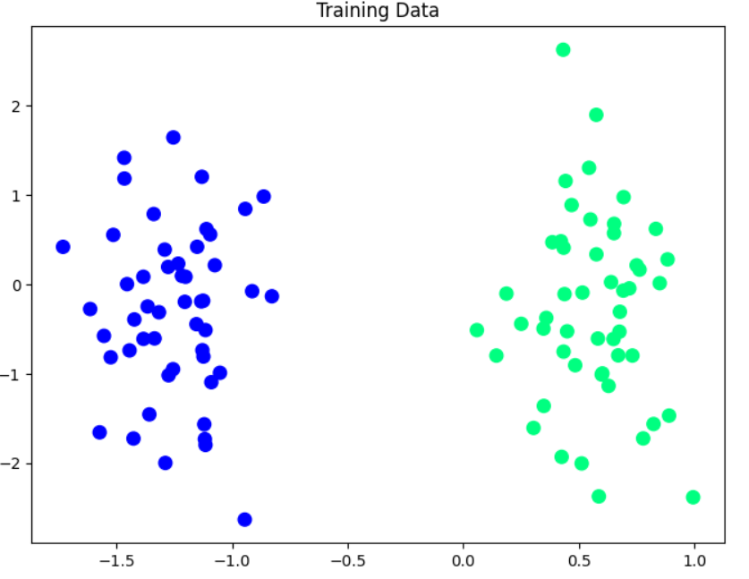
a). Data Visualization

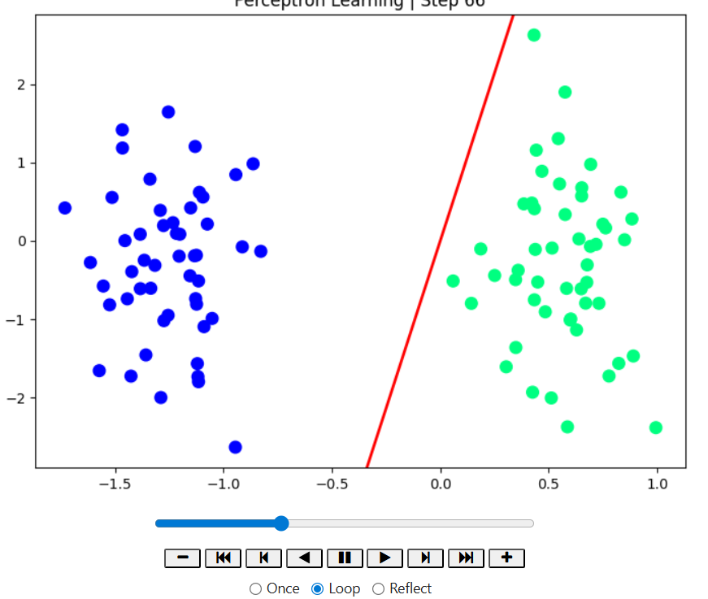
b). Showing Animation of w.T*X Line

